Courtesy of Municipal Sewer & Water Magazine October 2012
FOG programs are about education and prevention.
Not only does reduction in FOG save the public thousands of dollars in worn and damaged pipes and pumps at the treatment plant but FOG Programs keep businesses operating. "We extended an olive branch first to show we want them to be prosperous. We want all our customers to be successful because a successful business pays its water bill on time," Rob McElroy of Daphne Alabama Public Works.

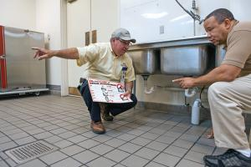
Good kitchen practices
Rex Rentz, code enforcement officer for Daphne Alabama, targets restaurant managers for an educational program on good kitchen practices. Training sessions and a training DVD show managers the best way to handle oil and grease in commercial kitchens. He regularly checks with employees to make sure they are handling fats, oils and greases properly in their areas.
"We work with them positively and calmly, and we assume people are trying to do the right thing. If they aren't, we will put them under a monitoring schedule. It's just a matter of education," Rentz says. “The last thing we want is for a sewer spill to happen in a restaurant and the Board of Health to shut it down. The code enforcement effort is one way we help people stay in business and keep them profitable."
11,000 teaspoons of oil…
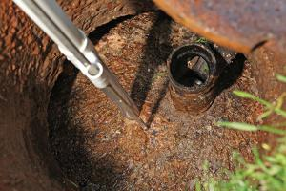
Commercial kitchens aren't the only contributors to fats, oils and grease in the sewer system. Residential customers are believed to be the biggest contributors to sewer blockages. To motivate change residential customers need to see how they can make small changes with a large impact.
As an alternative to pouring cooking oil down the sink or toilet residents are encouraged to throw grease in the garbage or recycle it at Grease reclaim facilities. Consumer education has also contributed to reducing grease buildup in the lines. The team in Daphne Ala. spoke with community groups and individuals about making small changes in the home. For example, using a paper plate to wipe off extra grease instead of rinsing it down the drain can have a beneficial impact on the sewer system.
Crust of Grease floating in Grease Trap
"If each home adds a teaspoon of grease down the sink every day, it adds up to seven 55-gallon drums of oil entering the sewer system every month,” Rob McElroy says. "If you saw someone pouring seven 55-gallon drums into a manhole, you would call the police because you'd be witnessing an environmental crime. It's the same thing."
http://www.mswmag.com/editorial/2012/10/cutting_out_the_fat

